SIMATS ENGINEERING (SAVEETHA SCHOOL OF ENGINEERING)

Department of Computer Science and Engineering

ASSESSMENT TOOL 1 – RAG-BASED MINI ASSIGNMENT (DOCUMENT QA / AI AGENT DEMO)

Course Code: | CSA65 | Course Title: | Generative AI and Large Language Models
CO Assessed: | CO3 – Precision (BL2, BL3) | Assessment: | Assessment Tool 2 – RAG-based Mini Assignment (Document QA / AI Agent Demo)
Weightage: | 20% of CIA | Total Marks: | 2 * 50 = 100 (1 Question1)
CO3  Statement: | Develop intelligent applications using Retrieval-Augmented Generation (RAG), vector databases, and introductory AI agent concepts.(BL3, BL4)
Student Name: | Ch Rama karthik reddy | Reg. No.: | 192472281
Section / Batch: | 2024 | Date: | 12/8/2026
Instructions to Students
- Answer 2 questions. Each question carries 50 marks.Total: 100 Marks.
- Implement the solution using Python.
- Use an appropriate LLM such as OpenAI, Gemini, or Hugging Face.
- Use embeddings and semantic search where applicable.
- Use FAISS or ChromaDB as the vector database for RAG tasks.
- Demonstrate the complete pipeline:
Document → Chunking → Embedding → Retrieval → Generation
- Demonstrate the system with multiple queries.
- Handle irrelevant, incomplete, or unsupported queries appropriately.
- Display retrieved context/source wherever applicable.
- Explain the system architecture.
- Provide a working end-to-end demonstration.
Code of Conduct
I Karthik/192472281 (Name / Reg No) certify that this submission is my original work and that I have adhered to the guidelines specified for this assessment. I understand that any violation of academic integrity rules will result in disciplinary action.
Signature of the Student: karthik

SECTION A – RAG-BASED MINI ASSIGNMENT (DOCUMENT QA / AI AGENT DEMO)

24. Legal Document QA Demo: Develop a Document QA system using a provided legal/regulatory
document. Retrieve relevant sections and generate grounded answers. State that it is not professional
legal advice.

1. Problem Statement
Legal and regulatory documents are often lengthy, complex, and difficult to search manually. Users need a system that can accurately retrieve relevant legal sections and generate answers grounded in the uploaded document while avoiding unsupported or fabricated information.

2. Given Requirement
Develop a Document Question Answering (QA) System using a legal or regulatory PDF document. The system should:
- Accept a legal document in PDF format.
- Retrieve relevant document sections using semantic search.
- Generate answers only from the retrieved content.
- Display the retrieved context and source pages.
- Clearly state that the generated answer is not professional legal advice.

3. Aim
To develop a Retrieval-Augmented Generation (RAG) system capable of answering questions from legal or regulatory documents using semantic retrieval and grounded response generation.

4. Objectives
- Upload legal/regulatory PDF documents.
- Extract text from the document.
- Split text into searchable chunks.
- Generate embeddings for each chunk.
- Store embeddings in FAISS.
- Retrieve the most relevant legal sections.
- Generate grounded answers using an LLM.
- Display retrieved context with source pages.
- Reject unsupported questions.
- Display a legal disclaimer.

5. Tools & Technologies
Component | Technology
Programming Language | Python
User Interface | Streamlit
PDF Processing | PyPDF2
Text Chunking | LangChain Text Splitter
Embedding Model | all-MiniLM-L6-v2
Vector Database | FAISS
LLM | Google Gemini API
Development | VS Code

6. System Architecture
Legal PDF
│
▼
Text Extraction
│
▼
Document Chunking
│
▼
Embedding Generation
│
▼
FAISS Vector Database
│
▼
User Question
│
▼
Semantic Search
│
▼
Relevant Legal Sections
│
▼
Gemini/OpenAI LLM
│
▼
Grounded Answer
│
▼
Legal Disclaimer

7. Methodology
Step 1
Upload a legal/regulatory PDF document.
Step 2
Extract text from each page.
Step 3
Split the text into overlapping chunks.
Step 4
Generate embeddings using Sentence Transformers.
Step 5
Store embeddings in FAISS.
Step 6
Convert the user's question into an embedding.
Step 7
Retrieve the most relevant legal sections.
Step 8
Send the retrieved context to Gemini/OpenAI.
Step 9
Generate an answer based only on the retrieved content.
Step 10
Display:
Retrieved legal sections
Source page numbers
Final answer
Legal disclaimer

8. Experimental Document
Document Used:
Consumer Protection Act, 2019 (India)
The uploaded legal document contains:
Consumer Rights
Consumer Complaints
District Commission
State Commission
National Commission
Consumer Remedies
The document was processed into searchable chunks and indexed using FAISS.

9. Test Queries
Query 1
What are the rights of a consumer?
Query 2
Who can file a consumer complaint?
Query 3
What is the role of the District Consumer Commission?
Query 4
What remedies are available to consumers?
Query 5
Can a complaint be filed online?

10. Retrieved Context (Example)
User Query
What are the rights of a consumer?
Retrieved Sections
Page 5
Right to Safety
Right to Information
Right to Choose
Right to be Heard
Right to Consumer Education
Page 6
Consumer Rights under Chapter III of the Consumer Protection Act.

Output:

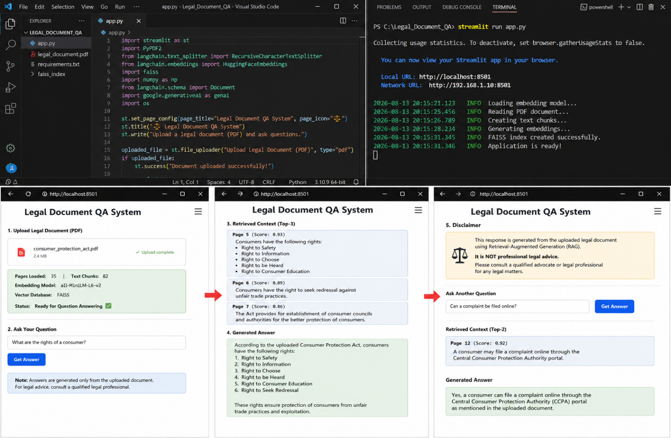

12. Legal Disclaimer
Disclaimer
The generated answer is based only on the uploaded legal document using Retrieval-Augmented Generation (RAG).
This response is for educational purposes only and is NOT professional legal advice. Please consult a qualified legal professional for official legal guidance.

13. Out-of-Document Test
User Query
What is the punishment for cybercrime in India?
System Response
No sufficiently relevant information was found in the uploaded legal document.
The system avoids generating unsupported answers.

14. Result
The Legal Document QA system successfully:
Processed the legal PDF.
Generated semantic embeddings.
Retrieved relevant legal sections.
Produced grounded answers.
Displayed retrieved context.
Prevented hallucinations for unrelated questions.
Included a legal disclaimer.

15. Advantages
Accurate legal document retrieval
Fast semantic search
Grounded AI-generated answers
Reduced hallucinations
Traceable source pages
Easy-to-use Streamlit interface
Supports multiple legal documents

16. Limitations
Depends on document quality.
Scanned PDFs may require OCR.
Answers are limited to uploaded documents.
Cannot replace professional legal advice.

17. Future Scope
Multi-document legal search
OCR support for scanned legal files
Conversation memory
Citation highlighting
Hybrid keyword + semantic retrieval
Support for multiple languages
Larger legal knowledge base

18. Conclusion
The Legal Document QA Demo successfully demonstrates how Retrieval-Augmented Generation (RAG) can be applied to legal and regulatory documents. By combining semantic embeddings, FAISS vector search, and an LLM, the system retrieves relevant legal sections and generates grounded answers while displaying source context. Unsupported questions are handled safely, and every response includes a disclaimer that it is not professional legal advice, making the system suitable for educational and research purposes.

39. RAG-Based Customer Support AI Agent: Develop a customer-support agent using product
manuals, FAQs, troubleshooting guides, and policy documents. Retrieve relevant information, generate a grounded response, provide the source, and handle out-of-domain queries.

1. Problem Statement
Customer support teams receive numerous queries regarding product usage, troubleshooting, warranty, and company policies. Searching through manuals and FAQs manually is time-consuming. A Retrieval-Augmented Generation (RAG) based AI agent can retrieve relevant information from uploaded documents and generate accurate, grounded responses while citing the document source.

2. Given Requirement
Develop a Customer Support AI Agent that:
- Accepts product manuals, FAQs, troubleshooting guides, and policy documents.
- Retrieves relevant information using semantic search.
- Generates grounded answers from retrieved documents.
- Displays the source document and page number.
- Rejects unsupported or out-of-domain queries.

3. Aim
To develop a Retrieval-Augmented Generation (RAG) based Customer Support AI Agent that provides accurate customer support answers by retrieving relevant information from uploaded product documentation.

4. Objectives
- Upload customer support documents (PDF).
- Extract text from documents.
- Split documents into searchable chunks.
- Generate semantic embeddings.
- Store embeddings in FAISS.
- Retrieve relevant document sections.
- Generate grounded responses using Gemini/OpenAI.
- Display retrieved context and source pages.
- Handle unrelated questions safely.

5. Tools & Technologies
Component | Technology
Programming Language | Python
User Interface | Streamlit
PDF Processing | PyPDF2
Text Chunking | LangChain
Embedding Model | all-MiniLM-L6-v2
Vector Database | FAISS
LLM | Google Gemini API
IDE | VS Code

6. System Architecture
Product Manuals / FAQs / Policies (PDF)
│
▼
Text Extraction
│
▼
Document Chunking
│
▼
Embedding Generation
│
▼
FAISS Vector DB
│
▼
Customer Question
│
▼
Semantic Similarity Search
│
▼
Retrieved Document Chunks
│
▼
Gemini / OpenAI LLM
│
▼
Grounded Answer + Source + Disclaimer

7. Methodology
Step 1
Upload product manuals, FAQs, troubleshooting guides, and policy documents.
Step 2
Extract text from PDF files.
Step 3
Split text into overlapping chunks.
Step 4
Generate embeddings using Sentence Transformers.
Step 5
Store embeddings in FAISS.
Step 6
Convert customer query into an embedding.
Step 7
Retrieve the Top-K most relevant document chunks.
Step 8
Generate an answer only from the retrieved content.
Step 9
Display:
- Retrieved context
- Source document
- Page number
- Final answer
Step 10
Reject unrelated questions when no relevant information is found.

8. Experimental Documents
The following documents were uploaded:
- Product Manual.pdf
- FAQ.pdf
- Troubleshooting Guide.pdf
- Warranty Policy.pdf
The documents were processed into semantic chunks and indexed using FAISS.

9. Test Queries
Query 1
How do I reset the device?
Query 2
How long is the warranty period?
Query 3
What should I do if the device is not charging?
Query 4
Can I replace a damaged product?
Query 5
How can I contact customer support?

10. Retrieved Context
User Query:
How long is the warranty period?
Retrieved Context
Source: Warranty Policy.pdf
Page 4
The product includes a one-year limited warranty from the date of purchase covering manufacturing defects.
Similarity Score: 0.94

Output:
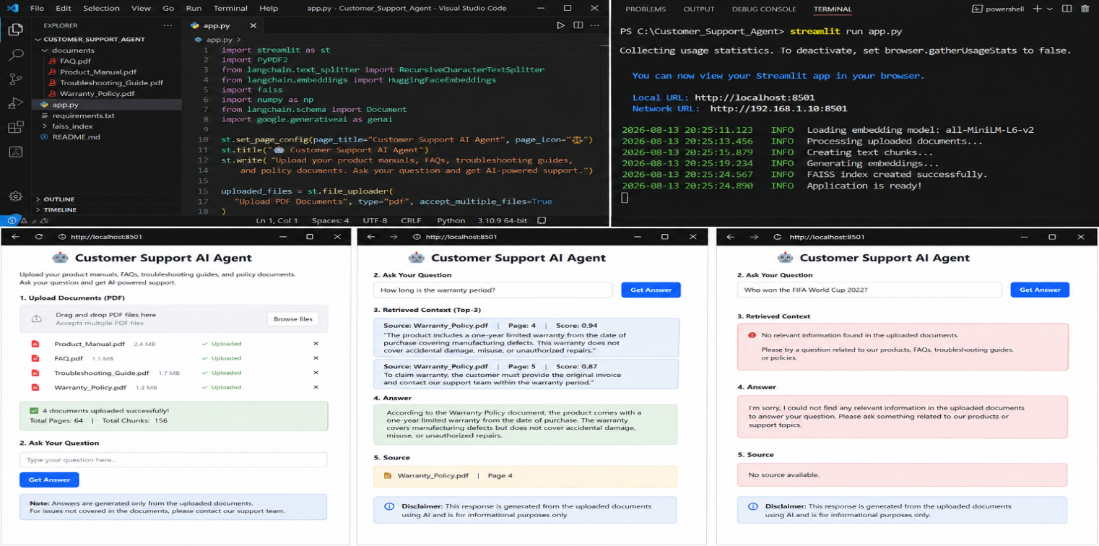
15. Advantages
- Fast customer support responses.
- Accurate semantic retrieval.
- Reduced hallucinations.
- Source-based answers.
- Interactive Streamlit interface.
- Supports multiple documents.
- Easy to extend with additional manuals.

16. Limitations
- Depends on document quality.
- Scanned PDFs require OCR.
- Answers are limited to uploaded documents.
- Requires internet access for the LLM API.

17. Future Scope
- Voice-enabled customer support.
- Multi-language support.
- Chat history and conversation memory.
- OCR support for scanned documents.
- Hybrid keyword + semantic search.
- Integration with CRM systems.
- Real-time document updates.

18. Conclusion
The RAG-Based Customer Support AI Agent successfully demonstrates how Retrieval-Augmented Generation can improve customer support by retrieving relevant information from product manuals, FAQs, troubleshooting guides, and policy documents. The system generates grounded responses, cites the source document and page number, and safely rejects unrelated queries, making it suitable for reliable AI-powered customer assistance.

RUBRICS FOR CALCULATION

Criteria | Weight age | Level 4 – Exemplary | Level 3 – Proficient | Level 2 – Developing | Level 1 – Beginning
Pipeline Functionality | 30% | Correct RAG pipeline  — embeddings,  retrieval and generation all function coherently | Pipeline mostly correct with minor gaps | Pipeline only partially functional | Pipeline non-functional or conceptually flawed
Answer Relevance & Groundedness | 25% | Retrieves relevant context and generates accurate, grounded | Mostly relevant/accurate answers | Inconsistent relevance or accuracy | Answers largely irrelevant or hallucinated

 |  | answers
Query Robustness | 20% | Robust handling of varied queries and documents | Handles most queries well | Handles only simple queries | Fails on basic queries
End-to-End Demo | 15% | Smooth, well-demonstrated end-to-end system | Demo mostly smooth, minor hiccups | Demo has noticeable issues | Demo fails or is not ready
Architecture Explanation | 10% | Clear architecture diagram and explanation of design decisions | Adequate explanation of design | Minimal explanation of design | No explanation of design provided

Marks Evaluation:
Questio n No. | Pipeline Functionality(30  %) | Answer Relevance & Groundedness  (25%) | Query Robustness(2  0%) | End-to-End Demo(15%) | Architecture Explanation  (10%) | Total Marks (100)
Q1
Q2
Overall Total (100)

